Contact: Simone Jung
simone@booksforward.com
615-450-0186
FOR IMMEDIATE RELEASE:

2-mil-copy-bestselling Brazilian author pens first English novel
Music, mystery, and coming-of-age in magical US YA debut
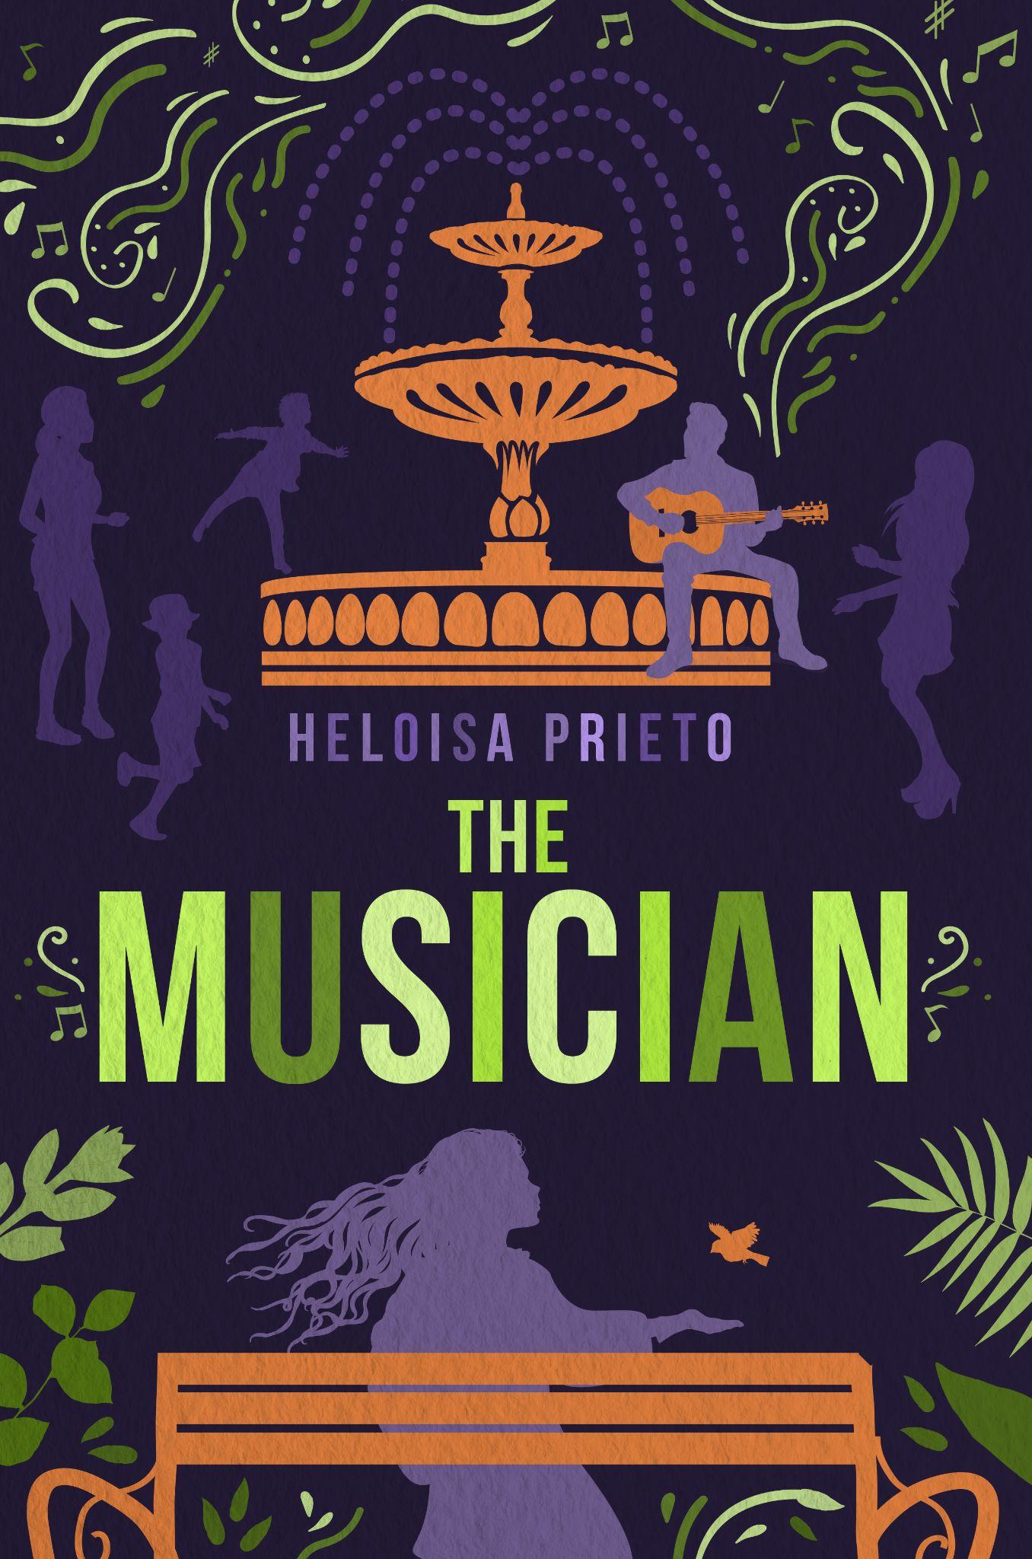
SÃO PAULO, Brazil– Sway to the beat of beauty and poetry in “The Musician” (Dec 13, 2022, Koehler Books) a new YA novel by multi award-winning Brazilian author, Heloisa Prieto. With over 2 million books sold in Brazil, Prieto is already a household name. But her long-standing success hasn’t stopped her from dazzling her readers with lyrical prose and spell-binding stories. With The Musician, she will debut her first English-written story within the US, uniting Brazilian mythology and the Guarani culture in a magical setting.

With the success of her Mano series in Brazil, Prieto’s books are no stranger to the limelight. Famous for her Mano series that was adapted into the 2011 International Film Festival for Children and Young Adults (FICI) award-winning film, “The Best Things in the World”, Prieto approaches her newest story in a different way creating a timeless and magical coming-of-age story filled with poetry, romance, and mystery.
“A musician and a healer share the same path; they spend their lives traveling, speaking beyond words, and rescuing ancient memories of wisdom and hope from people’s hearts.”

It follows a young Thomas whose only companions are the musical creatures only he can see. As a famous musician, he’s able to hide the lingering pain of his childhood using music as a form of connecting with the rest of the world. But when people find out about his magical creatures, they plan to steal it for themselves through seduction. With the help of Marlui, a young Guarani shaman, Thomas must face down his demons in this offbeat love triangle.
WATCH AN EXCERPT READING NARRATED BY SOFIA MARUCI

For fans of Paulo Coelho and Sally Rooney, readers will be entranced by this magical journey of self-discovery and the belief in the unseen.
“The Musician”
Heloisa Prieto | December 13, 2022 | Köehler Books | Contemporary magical realism
Hardcover | 978-1-64663-864-2 | $28.95
Paperback | 978-1-64663-862-8 | $15.95
Ebook | 978-1-64663-863-5 | $7.95
HELOISA PRIETO is one of Brazil’s most celebrated children and YA authors. She has sold over two million books in her native country. Her Mano series of YA novels inspired the Time Warner movie The Best Things in the World. She recently published 1,002 Ghosts, and her book Viajantes do Vento was selected for the PNLD Public-Book Purchasing Programme, the biggest of its kind in the world.

She has spent a lifetime researching myths and legends–both ancient and modern–and organizing and curating collections of cross-cultural interest. She has created and organized numerous creative writing workshops for children, teenages, and adults. Heloisa also has a PhD in French literature (University of São Paulo) and a master’s degree in semiotics (Catholic University of São Paulo). Find out more about her here.
Follow Heloisa on social media:
Facebook: Heloisa Prieto | Twitter: @heloisa_prieto | Instagram: @heloisa.prieto

In an interview, Heloisa can discuss:
- Her journey from writing as a young kindergarten teacher to releasing over 90 books with 2 million copies sold
- The impact Brazilian culture has had on this English language debut
- How she intertwines ancient myths with contemporary characters
- The importance of preserving and learning from indigenous traditions in the Brazilian forest, and how they inspired this story
- Her move into English-written stories and debut in the US

Advance Praise for The Musician

“There is magic in music, and Heloisa Prieto’s elegant prose captures the marriage of the two in a fanciful narrative that also touches the heart’s most profound truths. Accessible, readable, subtle, and often delightful, The Musician draws us forward with a fresh tale that carries deep messages of time, place and the integrity inherent in each soul, to be read slowly and savored for its whimsy, and its wisdom.”
– Greg Fields 2022 Winner, Independent Press Award for Literary Fiction

“‘The Musician’ is a beautifully crafted story involving elements of the supernatural; reminiscent of Edgar Allan Poe. Heloisa Prieto’s pen draws with bold strokes a kaleidoscope of characters in this unique story, explosive in its power to wrap the reader in a fabric of tension which is compelling and alive.”
– Claire Galligan, International Award winning Theater Director, Radio Producer, and Writer

“A narrative which by the magic of music leads us to resignify Orpheus' classical Greek myth intertwined by the fight for the indigenous forest people preservation and the urgent need to face the ecological issue that is threatening our planet. The characters of this entrancing book shall transform you, in a way or the other... “
– Maria José Silveira, Acclaimed award-winning Brazilian author of the awarded novel “Her Mother´s Mother´s Mother & her Daughters”
“While reading “The Musician” I experienced some of the pleasures which, according to Séan O´Faoláin, a creative narrative offers: the good yarn, suspense, reversal of expectation, effective use of language, identification and, above all, imaginative flight.”
– Dr. Munira Hamud Mutran. Doctor Honoris Causa On Literature, National University of Ireland, Maynooth, professor at the University of São Paulo.
“I really appreciated reading Heloisa Prieto’s The Musician. I believe it is very relevant for people to get acquainted with our cultural scenario and traditional wisdom. According to the Guarani teachings, artists don’t do their job just to entertain, but to touch people's hearts. We say that writers are warriors, in the sense that they are God gifted, so I believe her book will be very important as a way to show contemporary society a different world: ours.”
– Olivio Jekupé, indigenous writer from the Guarani nation has published 24 books, including bi-lingual editions (guarani-portuguese), having also been published in Italy.
“I was mesmerized by this narrative´s musicality, its rhythm, its repertoire, the quotes from actual songs, as well as poems and lyrics - all of them skillfully orchestrated by the author, offering the reader not only some truly thrilling scenes, as well as poetry and reflection.”
– Gabriella Mancini is an acclaimed Brazilian young TV, movie script writer, having worked at Netflix, TV Cultura, LC Barreto, Copa Studio, Gullane, among others
“Indigenous people are at risk, fighting to preserve not only the forests, but also the future of our children. The Musician really touched my heart by echoing voices that must be heard. Long life to the power of literature.”
– Dr. Katia Charada has a PHD on Literary Theory and History at Unicamp. (University of Campinas)
An Interview with
Heloisa Prieto

- The Musician is your first novel that was originally written in English. What made you decide to do that for this novel?

When indigenous rights to their land were violently threatened, I decided to create a narrative in which a contemporary and extremely successful young musician only finds peace by valuing and tuning to the rain forest dwellers mind set. My wish was to share, by the means of a contemporary fable, the relevance of the Guarani ecological way of thinking.

- Brazilian mythology plays a large part in The Musician. What drew you to these myths?

My father used to tell me that “when human madness harms the planet to catastrophic proportions, the indigenous people will take the lead, because they will be the only ones who can find the path under the stars”.
All along the years I spent listening to narratives from Brazilian indigenous authors, I realized their myths and legends focus on acceptance, inclusion and deep connection with Nature. Thomas is a sensitive artist whose heart is called by the forest without him knowing it. His inner call which will be sensed by beautiful Marlui will break the contemporary paradigm of early fame/untimely death.
In order to intertwine ancient myths with urban characters, I chose to tell the stories through the eyes of 5 different characters, whereas keeping the pace of life at risk thriller.

- What kind of research went into writing this novel?
My father, Luiz, was a great admirer of indigenous traditions. As a boy he made friends with people from the Guarani village and their teachings deeply influenced him. As an adult, he traveled to the Xavantes nation yearly. I heard his tales, his experiences among them and inherited his views. For thirty years now I have been giving my contribution by curating indigenous authors and translating their tales. Some years ago, when Estas Tonne came to Brazil, he played at the village and spoke to their healer. I was fascinated by the Guarani approach to sound healing. The chapter 5 strings was inspired by an actual experience at the praying house.

- This is your adult debut after a successful career writing childrens’ books. How did writing this novel differ from writing your others?

In Brazil I had been publishing both children’s books and YA novels. Lenora, my first gothic novel, had been inspired by Edgard Allan Poe’s works, yet it took place in Florianópolis, a tropical beach. When I first submitted The Musician to Koehler’s team I thought I had written another YA book, a thriller in a Brazilian scenario. However, maybe due to the choice for 5 different points of views, the retelling of Guarani myths and teachings in a contemporary scenario, editors thought the book should not be limited to a specific target reader. Although I love writing about and for the youth, I took it as a compliment in the sense that the narrative was considered all inclusive.

- What do you hope your readers take away from Thomas, Marlui, and the other main characters?

Poetry, beauty and peace can only be seized if we have “eyes to see” them. As in the rainforest beauty derives from diversity. Each character is meant to share a totally new horizon in order to enlarge one's inner landscape. What is a happy ending after all? Sometimes questions are more meaningful than answers. Life is a constant riddle whose answers can move us towards surprising scenarios.

